# 

# 

# 

# **ADBMS Lab**

**Submitted by: Submitted to:**

**NAME : Rahul Gusain Dr.Ankit Khare**

**SAP: 500084143**

**ROLL NO.: R214220900**

**BATCH: 1 DevOps**

**LAB 6**

**EXPERIMENT-6**

**Title: 6. To understand the concepts of Views.  
Objective:** Students will be able to implement the concept of views.

**1. Create table of table name: EMPLOYEES and add 6 rows**

| Column Name | Data Type | Width | Attributes |
| --- | --- | --- | --- |
| Employee_id | Character | 10 | PK |
| First_Name | Character | 30 | NN |
| Last_Name | Character | 30 | NN |
| DOB | Date |  |  |
| Salary | Number | 25 | NN |
| Department_id | Character | 10 |  |

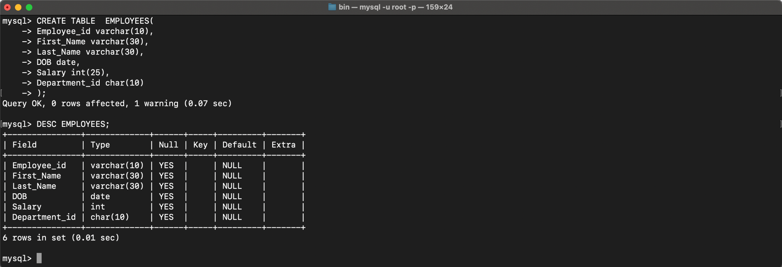

INSERT INTO EMPLOYEES VALUES ('7364','SMITH','MARK','1987-12-19','500','800');

INSERT INTO EMPLOYEES VALUES ('7365','JOHN','JOHN','1987-12-19','1500','802');

INSERT INTO EMPLOYEES VALUES ('7366','ROSS','GELLER','1987-12-19','5020','803');

INSERT INTO EMPLOYEES VALUES ('7367','MONICA','GELLER','1987-12-19','5500','804');

INSERT INTO EMPLOYEES VALUES ('7368','SMITH','CLERK','1987-12-19','5000','805');

INSERT INTO EMPLOYEES VALUES ('7369','RACHEL','GREEN','1987-12-19','10500','806');

SELECT * FROM EMPLOYEES;

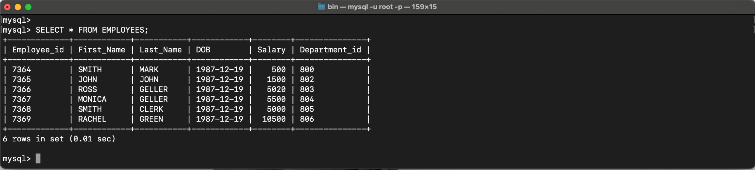

**2. Execute the following view related queries:**

1) Create View of name emp_view and the column would be Employee_id, Last_Name, salary and department_id only.:

CREATE VIEW emp_view AS SELECT Employee_id, Last_Name, salary, department_id FROM EMPLOYEES;

2) Insert values into view(remove the NOT NULL constraint and then insert values):

INSERT INTO emp_view VALUES ('7364','MARK','500','800');

INSERT INTO emp_view VALUES ('7365','JOHN','1500','802');

INSERT INTO emp_view VALUES ('7366','GELLER','5020','803');

INSERT INTO emp_view VALUES ('7367','GELLER','5500','804');

INSERT INTO emp_view VALUES ('7368','CLERK','5000','805');

INSERT INTO emp_view VALUES ('7369','GREEN','10500','806');

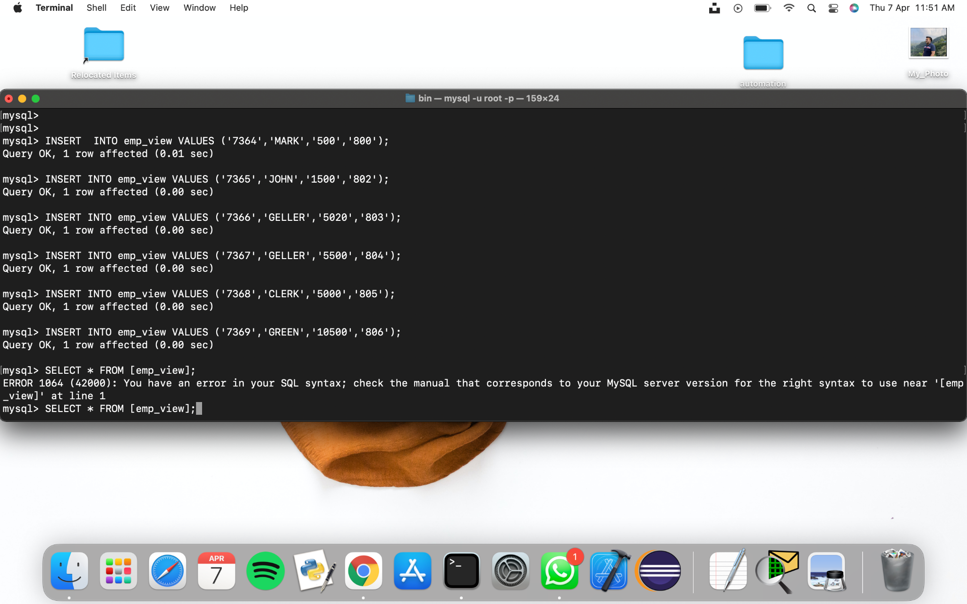

3) Modify, delete and drop operations are performed on view.:

CREATE OR REPLACE VIEW contacts AS SELECT Employee_id, Last_Name FROM emp_view;

DROP VIEW salary_view;

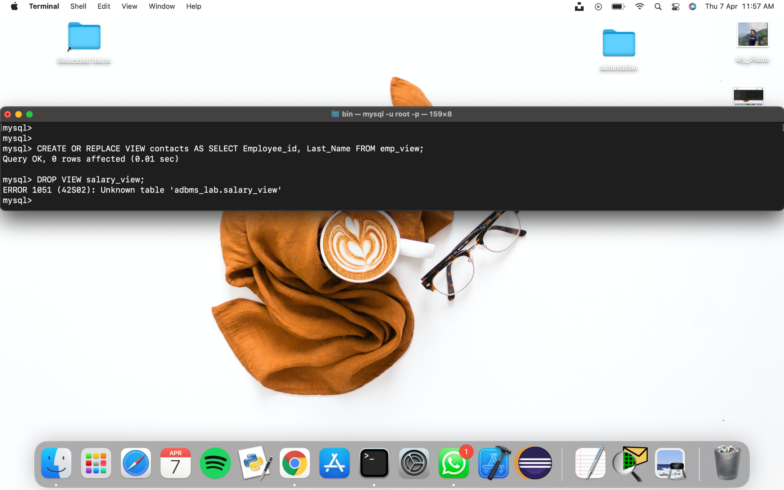

4) Creates a view named salary_view. The view shows the employees in department 20 and their annual salary.

CREATE VIEW salary_view AS SELECT salary, department_id FROM emp_view where department_id = 800;

SELECT * FROM emp_view;

